**SMART STAR EXAMINATIONS BOARD**

**END OF TERM ONE EXAMINATION - 2024**

**MATHEMATICAL CONCEPTS**

**MIDDLE CLASS**

My name is…………………………………………..

1. **Match the same.**
2. **2**
3. **3**
4. **4**
5. **5**
6. **1**
7. **Draw balls for the number.**

**6 =**



**3 =**

**5 =**

**10 =**

1. **Copy.**

|  |  |
| --- | --- |
|  | kit |
| **triangle** | **kite** |
|  |  |
|  |  |
|  |  |
| **oval** | **heart** |
|  |  |
|  |  |

1. **Count and circle.**

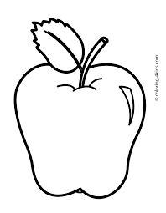 **2 4 9**



**4 6 2**

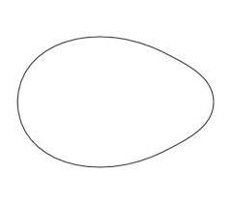 **1 6 3**



**0 2 1**

1. **Circle the correct number.**

2

2

**2**

**1**

1

1

3

**3**

4

3

**4**

4

**6**

6

6

**NICE HOLIDAY**